**ASSIGNMENT -6 (Numpy)**

**Harsh Chandrakar PRN-250840125020**

Set 1:

Create a 3×3 array of all True Boolean values

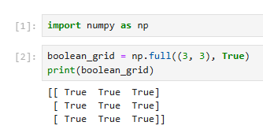

Extract odd numbers from an array

Replace all odd numbers with -1

Reverse columns of a 2D array

Get indices of elements greater than 5 [hint: check where method of numpy]

Access last row - last column

Set 2:

Normalize a NumPy array [ to normalize means scaling the values of an array into a specific range, often [0, 1]]

Create a 5×5 array with 1 on border and 0 inside

Create a random array of 10×10: perform stats (min, max, mean, std)

Broadcast a 1D array over a 2D array [all possible scenarios]

Scenario1

Scenario2

Sort a 2D array by column 1 [hint: check method argsort()]

Set 3:

Find common elements between two arrays [with and without using intersect1d]

#without intersect1d

#with intersect1d

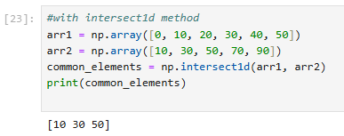

Subtract row mean from each row of a 2D array

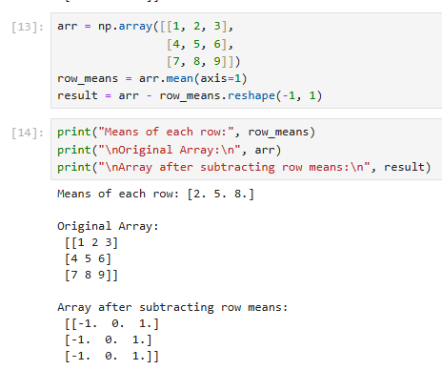

Given a 4×4 array, swap the first half rows with the second half rows

Given a 1D array of random numbers, find the indices of the 5 largest values (no sorting/ check argsort() instead).

From a 2D NumPy array, extract only the unique rows (no duplicates hint: check unique method).

